U08224 Graphics and Animation

Examination Rubric

The duration of the examination is 2 hours.
Answer ONE question from SECTION 1 and ONE question from SECTION 2. There are TWO questions in each SECTION.
All questions carry equal marks of 25

SECTION 1
(1)
(a) setup(), draw() and mousePressed() are three commonly used, built-in methods in Processing. Considering Processing as a graphics and animation programming language, state what is the general role of each of them and what relationship do they have to each other?
Setup – initialises the programme by running as soon as the code is invoked.
Draw – executes 60 (default) times every second. This rate can be adjusted. The draw() method is the usual way to produce animation by ‘splashing paint’ over the canvas and drawing the latest configuration of graphical objects.
mousePressed – is an event handler. Each time draw() finishes the system checks for any events that have occurred. If the mousePressed event has occurred the code in mousePressed is executed.
8 Marks

(b)
  - What is the effect of the data declarations and the setup() method in the programme below?
4 Marks
The values of d, W, H and RightShift are set to 120, 4 * d = 480, d = 120 and 0 respectively
Sets the size of the canvas to W * H – 480 * 120. Sets the fill colour of all shapes to Red until a new fill command is given
  - What is the effect of the draw() method in the programme below?
4 Marks
The canvas is coloured yellow. The RightShift value is incremented by 1 (pixel) and four red circles with diameters equal to the height of the canvas are drawn in a line touching each other, with the left side of the first circle at position RightShift
  - What is the effect of the mousePressed() method in the programme below?
The value of RightShift is set to 0
1 Mark

int d = 120;
int W = 4 * d,
H = d;
int RightShift = 0;

color Red = color(255, 0, 0),
Yellow = color(255, 255, 0);

void setup() {
size(W, H);
fill(Red);
}

void draw() {
int i;

background(Yellow);
for(i = 0; i < 4; i++) {
RightShift++;
ellipse(i * d + d/2 + RightShift, d/2, d, d);
}
}

void mousePressed() {
RightShift = 0;
}

(c) Using diagrams and text, describe the behaviour of the programme as seen by a user.
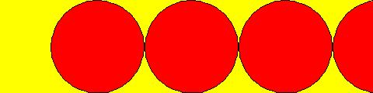
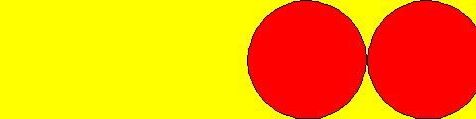

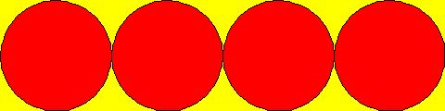
8 marks
4 red circles are displayed on a yellow background and immediately start moving to the right. Every time the mouse is pressed the circles return to their original position and start moving to the right again. The diagram shows a sequence of canvas captures.

(2)
(a) Why is an object oriented approach useful in graphics and animation?
4 Marks
We are looking for an account of modularity and its use in G and A

- Explain the relationship between class and object.
Class as template etc.
3 Marks

- Describe the typical attributes and methods a moving Square class might define.
Cx, Cy (Position), Side, colour, dx, dy (velocity)
Draw() – Draw itself
Strictly the constructor is not a method but no penalty for saying it is
4 Marks

- Write code for your Square class.
class Square {
int Cx,
Cy;
int Side;
color Col;

RectButton(int Cx, int Cy, int Side) {
this.Cx = Cx;
this.Cy = Cy;
thisSide = Side;
}

void Draw() {
rectMode(CENTER);
fill(Col);
rect(Cx, Cy, Side, Side);
}
5 Marks

- The top line of graphics below shows the evolution of a large number of random squares of various sizes and colours produced by a Processing programme. The larger graphic shows a more detailed screenshot.

- Why would an array be a useful data structure to use here?
3 Marks
To maintain a large number of Squares

- Describe how you would design and implement such a graphic using the array and the Square class. How is the approximate symmetry of the graphic achieved and maintained?
Any useful account based on this as one of 10+ demos seen and studied
6 Marks
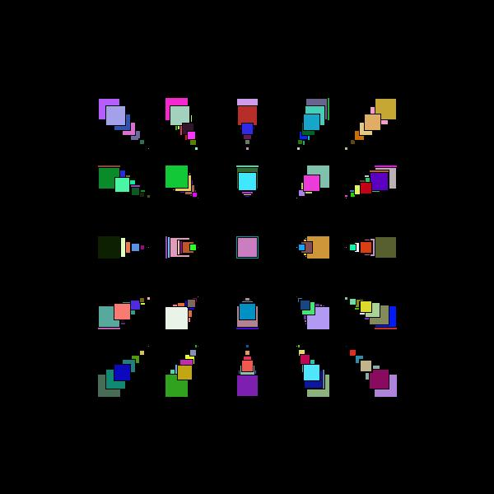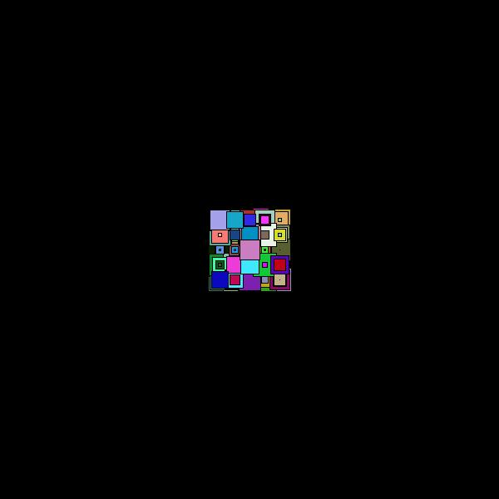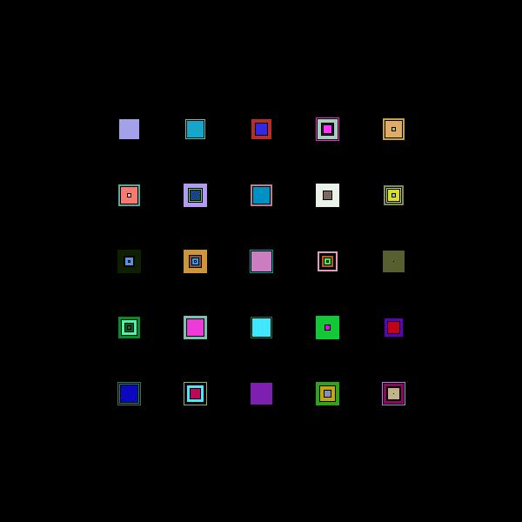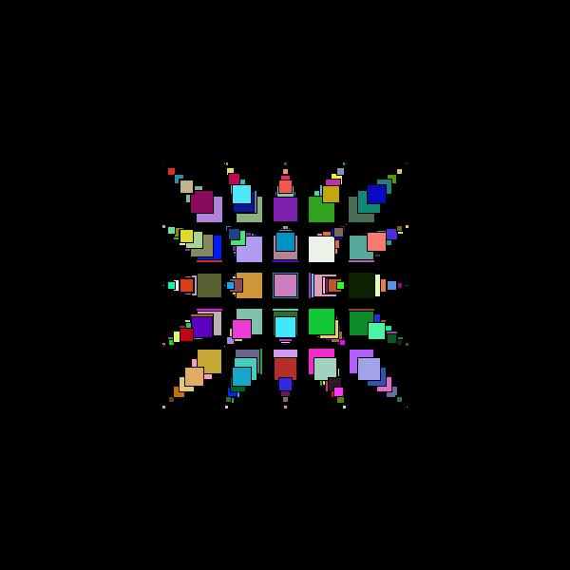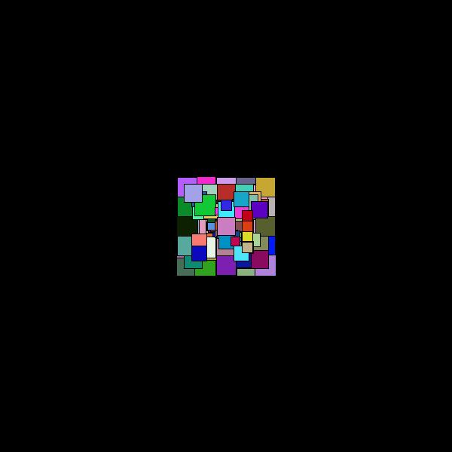

SECTION 2

(3) This question uses the programme on the sheet Code For Exam Question 3

- Explain what the code in box A does.
Draws a black ellipse
2 marks

- Explain what the code in box B does. In particular clearly explain the effects of translate() and rotate().
translate shifts the origin to (400, 200). rotate turns the axes through i * Unit radians before the red circle is drawn..
8 marks

- What is the effect of running the code in box A followed by the code in box B?
The effect is that the red ‘moon’ created in (b) circles the black ‘planet’ created in (a)
5 marks

- What is the role of the Processing methods pushMatrix() and popMatrix()?
Using pushMatrix() saves all the translations and rotations so that popMatrix() can restore the origin and axes to their initial state

5 marks

- What is the effect of running the whole programme?
Two stationary ‘planets’ each have a moon circling them. The angular velocity of each sun is the same.
5 marks
Total 25 Marks

(4)
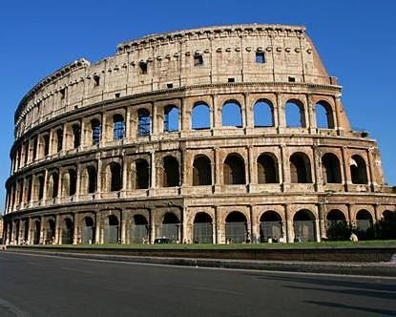
The program below takes an image for input and outputs a mirror image – see example.

void setup() {
PImage Im;
Im = loadImage("Colosseum.jpg");
size(Im.width, Im.height);
image(Im, 0, 0);
}

void draw() {
Colosseum.jpg
}

void mousePressed() {
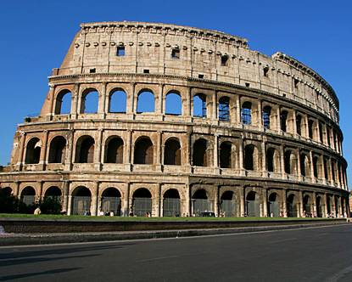
int i,
j;
color Save = 0;
for(i = 0; i < width/2; i++) {
for(j = 0; j < height; j++) {
Save = get(i, j);
set(i, j, get(width - i, j));
set(width - i, j, Save);
}
MirrorColosseum.jpg
}
save("MirrorColiseum.jpg");
}

- What does setup() achieve in this program? Explain your answer.
An Image reference is declared and the Image object, Colosseum.jpg is loaded into the programme. The canvas is set to the size of the image. The image is displayed with its top left corresponding to the canvas top left.
7 marks

- What does the method call get(i, j) achieve?
It obtains the RGB coding for the pixel at (i, j) and stores it in Save
3 marks

- What does the method call set(i, j, get(width - i, j)) achieve? K
This sets the pixel colour code for the pixel at (i, j) equal to its mirror reflection in the vertical line running down the centre of the canvas

4ppppppp
4 marks
4 marks

- How does the program produce the output image MirrorColiseum.jpg?
5 marks
The line set(width - i, j, Save) sets the pixel colour at (width - i, j) to the value of the saved pixel from (b). Combined with (c) this effectively swaps pixels the vertical line running down the centre of the canvas.
6 marks

Total 25 Marks

End of Examination Paper

